Question 1

Create a new Power BI Desktop file, and load the table of million-selling singles from *The Guardian*'s website.  You can get the link you need from [this webpage](https://www.wiseowl.co.uk/sundry/pbd1/).

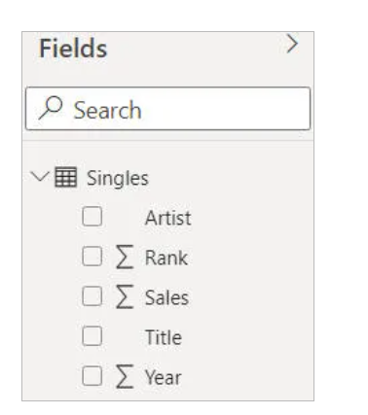

*Rename your table (and field names, if necessary) to make everything easier to read. Note that if you haven't got an Internet connection, you can load a CSV version of the file from the folder above.*

The aim of this exercise is to create two charts, and get choices you make in one to influence the other - instructions follow, so please read on!

*The two charts we'll (eventually) create.*

 Start by creating the following chart, or as close to it as you can get:

*Colour saturation has been set to colour charts according to the volume of sales, and data labels applied inside each column bar.  The chart is sorted by volume of sales (you could scroll right to see the less successful artists).*

Now create a pie chart which shows the volume of sales by year (it will look messy, because there are too many data points):

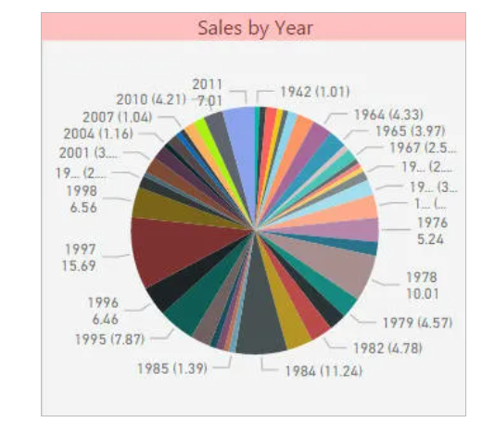

*Things will look better in a moment ...*

*The easiest way to format the second chart is just to paste the format settings from the first.*

Change your interactive visual settings so that when you click on an artist in the column chart, it filters the pie chart:

|  |  |
| --- | --- |
|  |  |
| *Column chart* | *Pie chart* |

Save this file as **Linked charts**, then exit this instance of Power BI Desktop.

Question 2

Create a new Power BI report, and load the CSV file from the above folder.  Use this to create a decomposition tree visual:

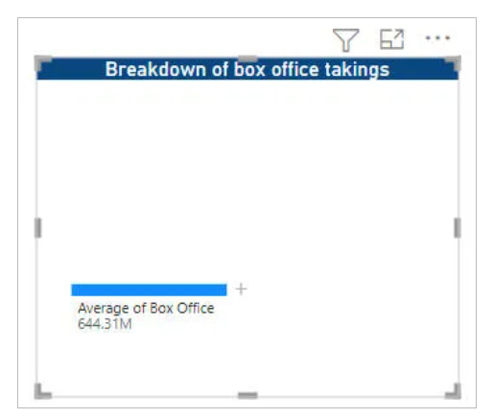

*Here we are showing the average box office takings by director, genre and certificate.  Unlike almost any other visual, you won't initially see any grouping levels.*

Expand the top node to show the average box office takings for **12A** **Comedy** films directed by **John Madden**:

*Note that you should also lock the certificate column to prevent anyone collapsing it.*

Now see how many of the following tricks you can apply:

*See below for some ideas of things to do!*

In the above visual we've made the following changes:

1. When you click on a node, it should expand or collapse it automatically.
2. Each data bar should show the amount relative to that shown in the total node (ie 644.31 million).

Save your report as **Visually appealing**, then close it down.

Question 3

Create a new Power BI Desktop file, and load the data from the workbook in the above folder (you can get a link to the figures [here](https://www.wiseowl.co.uk/sundry/pbd1/), should you be interested in further research!).

Create a pie chart showing the average number of viewers by program:

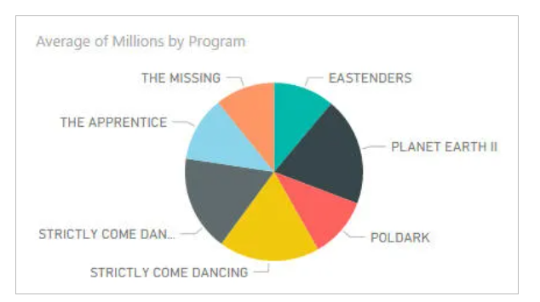

*This pie chart probably makes sense - it shows the share of each program of total viewing figures (for the top 10 programs on the BBC in the first week of November 2016).*

Create four groups for the programs:

*Four groups that you could create. You can start the process off by right-clicking on one or more of the pie chart slices and choosing****Groups****.*

Use these to show a less meaningful (albeit prettier) pie chart:

*Is it meaningful to show the average viewing figures by genre? Probably not, but it makes for a good exercise.*

Save this as **Demelza for PM**, and close down the Power BI instance containing it.

Question 4

Open the Power BI report in the above folder.  The data shows the number of completed tests by exam for each month of 2018 from the Wise Owl skills assessment site:

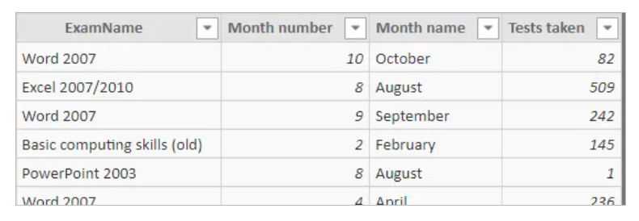

*For example, 82 tests were completed for Word in October 2018.*

Create a waterfall chart showing for each month the two leading causes of a change in the number of tests taken (with everything else lumped together as **Other**):

*Unsurprisingly, the yellow****Other****category is often the biggest.*

Save this report as **May the force be with you**, then close it down.

Question 5

Open the file called **Class Days.pbix** from the folder shown above.

Add a stacked column chart with **Day of Week** on the X-axis and **Average of Attendees** on the Y-axis.

Add a new page and switch to the **Format page** pane. In the **Page information** section switch on **Allow use as tooltip**.

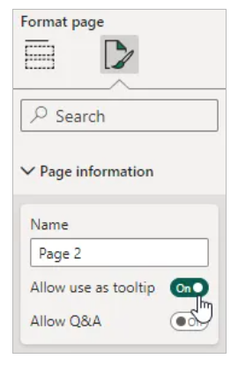

*Switching this on will also resize the page to tooltip size.*

*You can hold****Ctrl****and scroll your mouse wheel to zoom in to the page.*

Add a text box to the new page with the following text:

Question 6

Open the **Music Tours - Dynamic Labels.pbix** file in the folder shown above. You can use the chart on the **Menu** sheet to select an artist, then hold **CTRL** and click a button to see either the artist's album details or tour details.

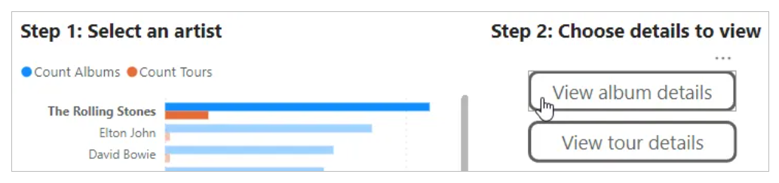

*When the report is published, the user can click the button without holding****CTRL****.*

Create a measure which returns the name of the selected artist. Create a card visual at the top of the **Albums** and **Tours** pages and assign the measure to each.

*Formatting the card to align it with the text box is probably the most challenging part of this!*

Create a measure which lists album titles along with their year of release, sorted in order of release date, separating each album with a new line character. Assign this measure to the tooltips of the pie chart on the **Albums** page.

*You can use****UNICHAR(10)****to insert a new line character.*

Create a measure which lists track names, sorting them by the **Track order** column. Add a gold star emoji next to tracks which reached number 1 in the US Billboard Hot 100 chart. Assign this measure to the tooltips of the column chart on the **Albums** page.

*You can display the emoji picker by holding the Windows key and pressing****.***

Create a measure which lists show dates and venues, sorted in order of show date and separating each with a new line. Assign this measure to the tooltips of the column chart on the **Tours** page.

*You might find the****RELATED****function useful for this example.*

Create a measure which lists countries and the count of shows performed in them. Separate each country with a new line and sort them alphabetically. Make sure to only include countries which had shows performed in them. Assign this measure to the tooltips of the pie chart on the **Tours** sheet.

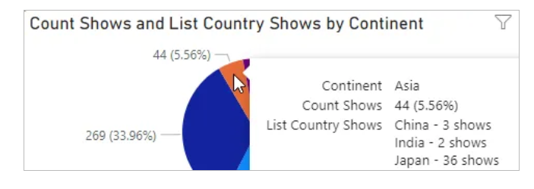

*You can use the existing****Count Shows****measure to help with this example.*

Save and close the report.

Question 7

Open the file called **Movie Data.pbix** from the folder shown above.

Add a **Treemap**chart with **Certificate**in the **Category** bucket and **Sum of Box Office Dollars** in the **Values**bucket.

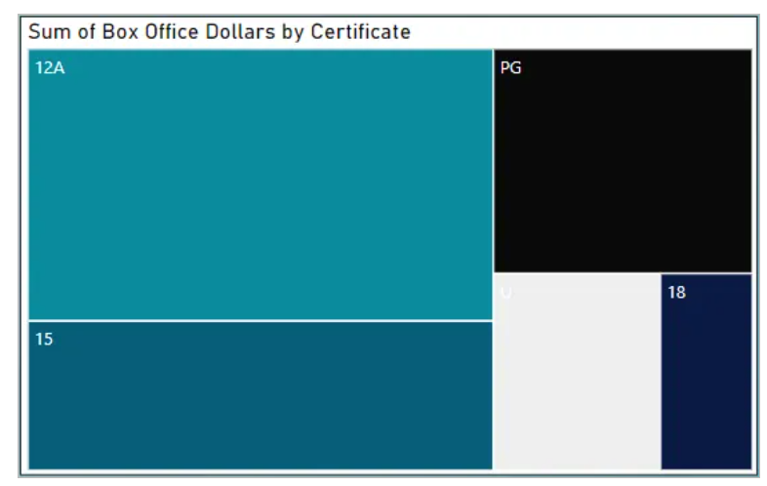

*It's a rectangular****Pie****chart!*

Add extra **Tooltips**for the following

* **Average of Box Office Dollars**
* **Sum of Budget Dollars**
* **Sum of Oscar Nominations**
* **Sum of Oscar Wins**
* **Sum of Run Time Minutes**
* **Count of Title**

Change the labels to something more appropriate and add a new **Title**to the chart. When you hover over a **Category**you should see something like below.

*You can change the colours used in the****General****section of formatting*

Save the file as **Tip of the Iceberg.pbix**

Question 8

Open the Power BI report called **Love Island.pbix** in the above folder.  The slicer works well, but the gauge needs a bit of illumination:

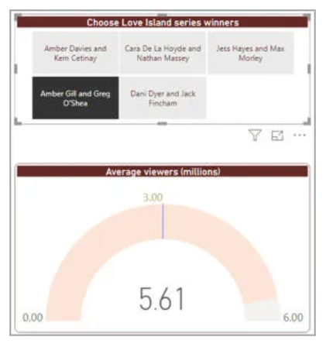

*Your task is to show a help tip for the gauge's visual header.*

Create a visual header tooltip page, and add the image in the same folder to this:

*Here we've set a title for the image too, and are showing the page actual size.*

Arrange for this page to appear as follows:

*When you hover over the question mark icon, you should see your tooltip page.*

Save this report as **Gauge of interest**, and close it down.

Question 9

Open the Power BI report file in the above folder.  It shows the 100 bestselling books since 1998:

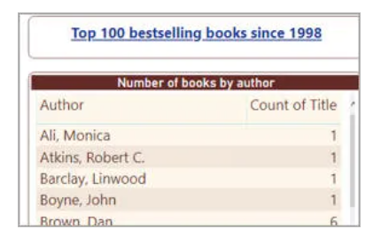

*One author appears twice as many times as his or her nearest competitor in the list, as you'll see if you sort the second column into descending order.  See if you can guess who this is before sorting!*

Create a tooltip page to show the volume of sales for each title:

*Your tooltip page doesn't have to look like this, or even be a bar chart.*

Assign this page to be the tooltip for the original visual:

*What you might see if you hover over****Bill Bryson****, for example.*

If you still have time, and want a challenge, create and display a quick measure to show the name of the author in your tooltip:

*The report page tooltip now shows the name of the author chosen in the title.*

Save this report as **Bookie tips**, then close it down.

Question 10

Load the Excel data from the above file and create a chart showing each dino by group and length:

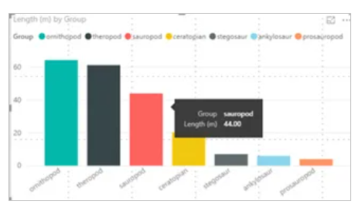

*While the chart looks good, the same can't be said for the boring tool tip!*

Add another report page. Set the new page to be a tool tip:

*It's also a good idea to set the page view on the****View****tab at the top of the page to****Actual Size****.*

Now highlight the original chart and assign the new page as the tool tip:

*This means that you can have different tool tips for different visuals!*

Finally make the tooltip page into a nice page to look at:

*A nice alternative to using****Drill-through****or****See data****options.*

Optionally save this as **Top Tyrannosaurus tips**, then close it down.

Question 11

Open the file called **Class Days.pbix** from the folder shown above.

Add a stacked column chart with **Day of Week** on the X-axis and **Average of Attendees** on the Y-axis.

Add a new page and switch to the **Format page** pane. In the **Page information** section switch on **Allow use as tooltip**.

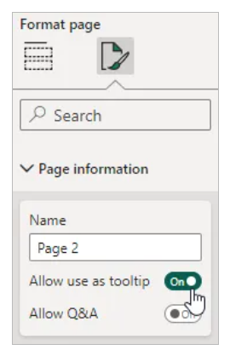

*Switching this on will also resize the page to tooltip size.*

*You can hold****Ctrl****and scroll your mouse wheel to zoom in to the page.*

Add a text box to the new page with the following text:

Hover over a column to see the Average attendees by Gender for each day. You can see the Average attendees by Location in the table below.

Add a table visual to the same page displaying the **Location**and **Average of Attendees** columns.

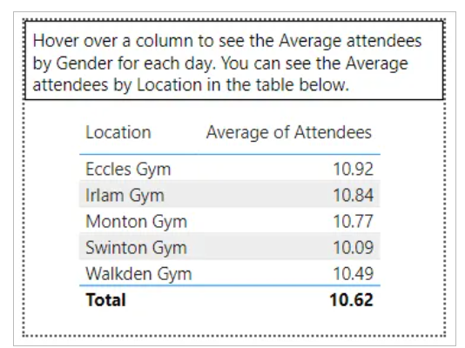

*Position the visuals as you prefer.*

On **Page 1**, select the chart and go to the **Header icons** section in **General**formatting. Switch on the **Help tooltip** and set the **Type** to **Report page** and the **Page** to **Page 2**.

*The****Help tooltip****section will only appear once you've turned on the****Help tooltip****option.*

Hover over the question mark icon in the visual header of the chart to see the tooltip.

*The visual header tooltip is very useful!*

Now to create the dynamic tooltip! Add a new page and switch on its **Allow use as tooltip** setting.

Add a **Pie**chart with **Gender**in the **Legend**bucket and **Average of attendees** in the **Values**bucket.

*Resize the chart to fill the page.*

On **Page 1** select the column chart and go to the **General**section of the **Format visual** panel.

*Set the****Tooltips | Options****to use the newly created page.*

Hover over different columns to see how the pie chart is affected.

*Unlike the visual header tooltip, dynamic tooltips change.*

To finish off the report hide the two tooltip pages so they are not visible when published.

Save the file as **Tooltips are cool.pbix**

Question 12

Open the report in the above folder:

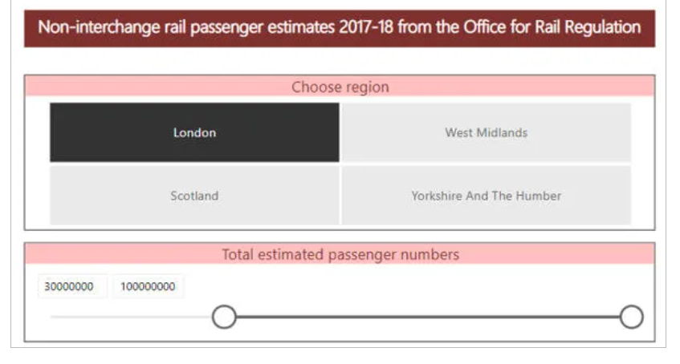

*The report contains data on UK station usage in 2017-18, broken down by ticket type.  The data is genuine!*

Create a map showing the usage of stations for the region and passenger numbers chosen in the slicers:

*This is only a suggestion for how your map could look.  Make sure you display the****Passengers****column on your chart, not the****Estimated Passengers****one.*

Add a tooltip field so that you can see which station you're looking at:

*This shows that we are looking at Waterloo station (as it happens, the busiest station in the UK).*

Add a table which shows the data for the pie chart slices you select:

Save this report as **Meeting your Waterloo**, then close it down.

Question 13

Open the Power BI file called **Movie Data.pbix** from the folder above.

Add a table visual with **Oscar Wins** and **Box Office Dollars**.

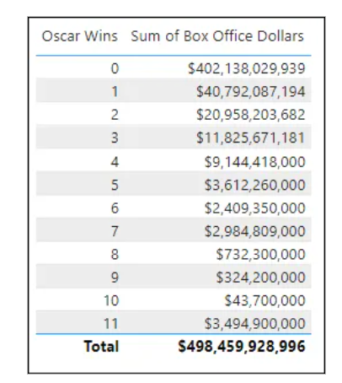

*Set the****Oscar Wins****column to not summarise.*

*You can stop a column from summarising data by clicking its dropdown in the columns bucket of the field well and choosing the****Don't summarize****option.*

Now we'd like to divide each **Sum of Box Office Dollars** value by the total. To do this, create two quick measures in the **Film** table:

* Create a quick measure giving the total **Sum of Box Office Dollars** with filters not applied.

*This will be our denominator. Rename this measure as****Total Box Office unfiltered****.*

* Create a quick measure to divide the **Sum of Box Office Dollars** by the previously created quick measure.

*Rename this measure as****% of unfiltered total****and format it as a percentage.*

Add the **% of unfiltered total** measure to the table visual.

*Unsurprisingly, the non Oscar winners have the highest percentage!*

Add a slicervisual using **Oscar Wins** and set it to filter between 2 and 10 wins.

*The data being shown makes up 10.44% of the total Box Office value.*

 Now create a quick measure to show each **Sum of Box Office Dollars** value as a percentage of the filtered total.

* Create a quick measure for the denominator giving the total value with filters applied.
* Create a quick measure to divide the **Sum of Box Office Dollars** by the previously created denominator.

*Rename the left hand measure as****Total Box Office filtered****and the remaining measure as****% of filtered total****.*

Format the **% of filtered total** as a percentage and add to the table visual.

Change the slicer values and observe each % of total measure.

*This example shows the percentages for between 3 and 7 Oscar wins.*

Save the file as **Not so quick.pbix**